**SELF-POWERED SMART GLOVE FOR RECOGNIZING BEHAVIOR BASED ON MACHINE LEARNING**

**ZHANG SHAO KANG**

**MASTER OF SCIENCE**

**CITY UNIVERSITY OF HONG KONG**

**AUGUST 2025**

**CITY UNIVERSITY OF HONG KONG**

**香港城市大學**

**Self-powered Smart Glove for Recognizing Behavior Based on Machine Learning**

**基於機器學習的自供電智能手套物體識別行為的實現**

**Submitted to**

**Department of Mechanical Engineering**

**機械工程學系**

**in Partial Fulfillment of the Requirements**

**for the Degree of Master of Science**

**理學碩士學位**

**by**

**Zhang Shao Kang**

**張紹康**

**Aug 2025**

**二零二五年八月**

Abstract

This study utilized triboelectric sensors and machine learning to design a smart glove that recognizes objects through grasping behavior. The human body mainly recognizes objects through two sense organs—vision and touch, in which vision plays an important role as the core organ of object recognition. However, if the object is in a low light environment or the recognized object is obstructed, it will be very difficult to use visual senses for object recognition. Therefore, this study designs a smart glove that recognizes objects by grasping different objects with five fingers in different postures.

In this study, the smart glove equipped with a microcontroller is used to simultaneously measure the bending of five fingers using triboelectric sensors, and machine learning classifiers—SVM, CNN, and KNN are used to achieve object recognition. In the experiment, several daily items with different shapes or sizes were prepared, such as table tennis balls, tennis balls, mice, glue, etc. According to the experimental results, the smart glove successfully achieved real-time object recognition, with recognition accuracies of % %and % for the three machine learning models, respectively. The smart glove developed by this research is expected to be applied in fields such as blind assistive gloves area.

**CITY UNIVERSITY OF HONG KONG**

**MASTER OF SCIENCE IN MECHANICAL ENGINEERING**

**DISSERTATION ACCEPTANCE**

|  |  |  |  |
| --- | --- | --- | --- |
| NAME OF STUDENT |  | : | _______________________________ |
|  |  |  |  |
| DISSERTATION TITLE (English) |  | : | _______________________________ |
|  |  |  |  |
| DISSERTATION TITLE (Chinese) |  | : | _______________________________ |

This is to certify that the student’s thesis (as presented above) has been examined by the following examiners and has received full approval for acceptance in partial fulfillment of the requirements for the Degree of Master of Science in Mechanical Engineering.

|  |  |  |
| --- | --- | --- |
| ___________________________ Name of supervisor |  | Department of Mechanical Engineering  City University of Hong Kong |

Dated this ____________________

(Signature of your supervisor)  
  
_____________________________   
(Name of supervisor)

Chair  
Panel of Examiners  
City University of Hong Kong

*(please ask your supervisor to sign before submission)*

Acknowledgements

Contents

|  |  |
| --- | --- |
| ??   Heading of chapter N | ?? |
| A   Heading of appendix A | ?? |
| … |  |
| Bibliography |  |

Abstract 1

Certification of approval 1

Acknowledgement 1

Contents 1

List of figures 2

1. Introduction 2

1.1 Research background 6

1.2 Research objective 7

2. Literature review 2

2.1 Human grasping behavior 6

2.2 Hand wearable devices measure joint movement 7

3. Research method 5

3.1 Structual design of smart glove 5

3.1.1 Hardware structure 5

3.1.2 Software structure 6

3.1.3 Properties of triboelectric sensors 7

3.2 Support vector machine model 6

3.3 K-nearest neighbor model 7

3.4 Convolutional neural model 7

4. Data collection and data preprocessing 7

4.1 Data collection 7

4.2 Data preprocessing 8

5. Establishment and training of ML models 16

5.1 Support vector machine 16

5.1.1 Establishment 16

5.1.2 Training 16

5.1.3 Recognition 16

5.2 K-nearest neighbor 16

5.2.1 Establishment 16

5.2.2 Training 16

5.2.3 Recognition 16

5.3 Convolutional neural 16

5.3.1 Establishment 16

5.3.2 Training 16

5.3.3 Recognition 16

6. Discussion 16

6.1 Summary 16

6.2 Prospect 16

Appendix 18

Reference 18

List of Figures

|  |  |  |
| --- | --- | --- |
| 1 | Caption of figure 1 | Page no of fig 1 |
| ….. | | |

Chapter 1

**Introduction**

1.1 Research background

Human beings need to recognize various objects every day, mainly relying on two senses to recognize surrounding objects-vision and touch. When these two types of ‘sensors’ receive object signals, the brain will judge and recognize the object based on personal cognition. However, in environment with no light or insufficient lighting, or when objects are partially obstructed, it is difficult to recognize objects using visual sensors. Therefore, this study utilizes triboelectric and piezoelectric sensors to recognize and judge objects, allowing users to use smart glove to recognize objects.

1.2 Research objective

The objective of this study is to design a wearable smart glove with triboelectric and piezoelectric sensors installed on each finger to measure the degree of finger bending when grasping objects. And using machine learning classifiers, the voltage signal data of smart gloves grasping objects of different shapes can be learned and predicted to create a high-precision and low-cost sensing device.

Chapter 2

**Literature Review**

2.1 Human grasping behavior

Exploratory Procedures (EPs) refer to a set of systematic, goal-directed hand movements that humans employ to extract specific object properties through active tactile exploration. According to the seminal work of Lederman and Klatzky (1987), six primary EPs have been identified, each optimized for acquiring distinct types of object attributes. Lateral motion involves back-and-forth movement of the fingers or hand across a surface and is the most effective procedure for assessing texture, as the vibrations generated during frictional contact encode information about roughness, granularity, and surface patterning. Pressure entails applying perpendicular force to an object's surface to evaluate mechanical properties such as hardness, elasticity, and compressibility, which is particularly useful for distinguishing between materials with different structural compliance. Static contact requires maintaining stationary hand-object contact to facilitate thermal perception, allowing the detection of material-specific heat conductivity and temperature differences through thermoreceptors in the skin. Unsupported holding involves lifting an object to assess its weight and mass distribution by sensing the muscular effort required to counteract gravity, providing critical information about an object's density and internal weight distribution. Enclosure is characterized by molding the hand around an object to obtain global shape and volumetric information, serving as an initial coarse representation of the object's overall geometry. Contour following employs precise fingertip tracing along object edges to extract fine-grained shape details, including curvature, sharpness, and surface relief, enabling the discrimination of complex geometric features. These EPs are not mutually exclusive but are dynamically combined in natural exploration, with their selection and sequencing being influenced by both task demands and object properties. The neural substrates underlying these exploratory strategies have significant implications for haptic interface design, robotic manipulation, and sensory substitution systems, making their study crucial for advancing human-machine interaction technologies.

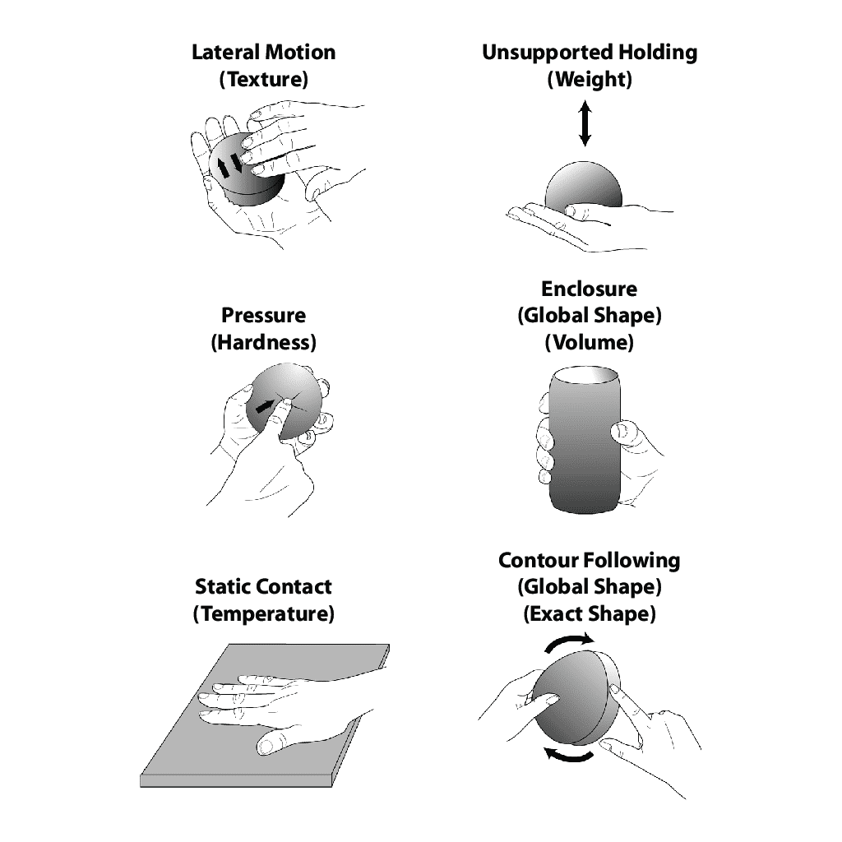

Figure 1 Exploratory procedures

2.2 Hand wearable devices measure joint movement

In 2022, Kok Tong Lee presents a smart glove with an object recognition (sphere; cuboid; cylinder) feature using the support vector machine (SVM), a supervised machine learning algorithm. A smart glove was fabricated using five resistive flex sensors. The flex sensor was characterized. A microcontroller was used to receive and process the data from the flex sensor and transmit it to a PC for machine learning and prediction. The SVM model was trained using 160 training data set (200*80%), and the trained model could be used to recognize three objects with different shapes(different shapes hold the objects) with an accuracy of 91.88%. The proposed AI-based smart glove has shown high accuracy in object recognition.

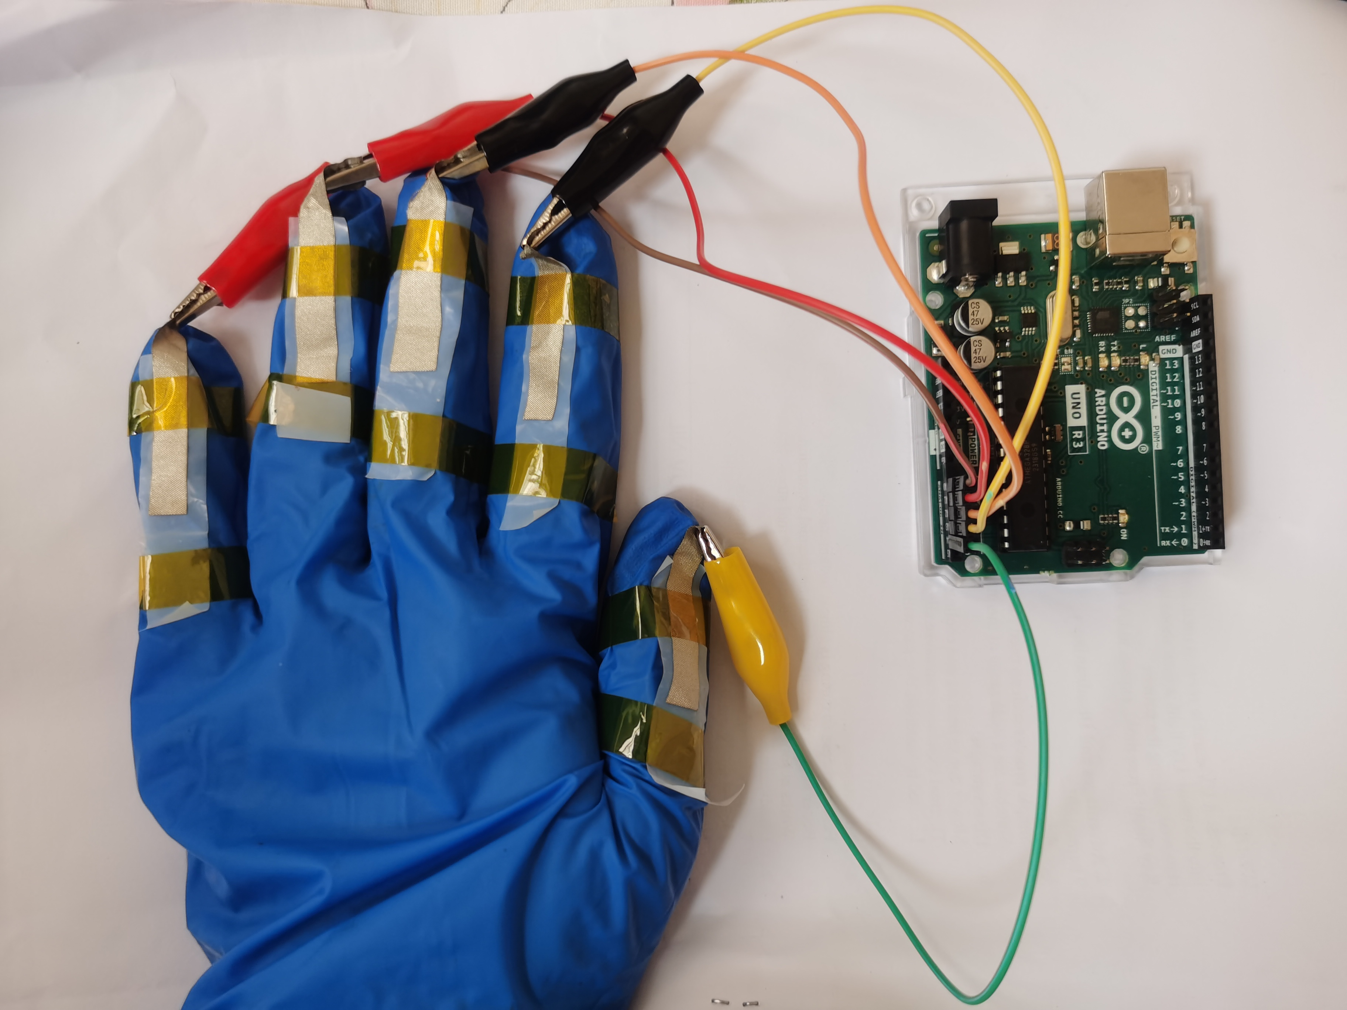

Figure 4 Structural manufacturing of smart gloves

Appendix A

**Appendix heading**

Here you have the contents for the appendix.

Bibliography

[1]